PERIODIC TABLE

BEHAVIOUR OBJECTIVES
At the end of this lesson, students should be able to;
- discuss the history of the periodic table.
- state the periodic law.
- differentiate between a group and period of elements.
- list the 8 groups and 7 periods of elements with 2 examples of elements in each classification.
- specify and name the 4 blocks of elements and give 3 examples in each block of the periodic table.

HISTORY OF PERIODIC TABLE
Periodic table is the arrangement of elements according to their atomic numbers. The history of the periodic table can be traced back to the mid-1800s. Lavoisier made the first attempt to classify elements. He classified into metals and non-metals. In 1869, Dmitri Mendeleev, a Russian chemist developed the first periodic table. He arranged elements in order of increasing relative atomic mass, and he developed a law. Mendeleev’s periodic law states that the properties of the elements varied periodically with their atomic mass.
Mendeleev’s periodic table had many gaps. He predicted that there were undiscovered elements which could fill the gaps, and he predicted the possible properties of these elements. Later, elements such as scandium, gallium were discovered, which not only fitted into Mendeleev’s table but also had the properties predicted.
As time passed, with the discovery of the electronic structure of atoms, it became clear that elements vary regularly with their atomic number but not with their relative atomic mass. So, in the modern periodic table, elements were arranged in increasing order of their atomic numbers and this was done by another scientist called Henry Moseley.

MODERN PERIODIC LAW
The modern periodic law states that the properties of the elements are a periodic function of their atomic number.

FEATURES OF THE PERIODIC TABLE
The modern periodic table is divided into eight vertical columns known as Groups and seven horizontal rows known as Periods.

Groups
The vertical columns of the periodic table. they are numbered from 1 to 18, from left to right. Elements in the same group have the same number of electrons in their valence shell, also similar physical and chemical properties.

Periods
The horizontal rows of the periodic table. They are numbered from 1 to 7, from top to bottom. Elements in the same period have the same number of electron shells. The number of valence electrons of the elements in the same period increases progressively by one across the period from left to right.

BLOCKS OF ELEMENTS
The periodic table can be divided into four main blocks. These are s-block, p-block, d-block and f-block. This division is primarily based upon their electronic configuration. Elements are divided into blocks according to the orbital their valence electrons are found.
Group 1 and 2 elements are s-block elements, they have their valence electrons in the s-orbital, while Group 13 to 18 are p-block elements, they have their valence electrons in the p-orbital. Transition elements are d-block elements, while lanthanides and Actinides are f-block elements, since their valence electrons is in f orbital.

PERIODIC TABLE SHOWING BLOCKS OF ELEMENTS
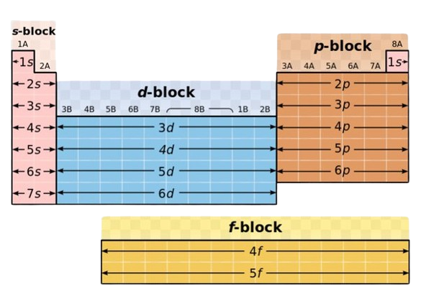

DRILL QUESTIONS

- Mendeleev’s periodic table was arranged in order of their ______?
- Atomic numbers
- Molecular shapes and orbitals
- Increasing relative atomic mass
- Orbital configuration

- s-block elements of the periodic table are made up of ______
- Group 1,2,3
- Group 1 and 2
- Group 3 to 7
- Group 3

- Elements in the same group of the periodic table have the same ______?
- electronic configuration
- atomic number
- number of valence electrons
- number of electrons

- In the Modern periodic table, elements are arranged in order of increasing ______?
- Atomic masses
- Mass numbers
- Valence electrons
- Atomic numbers

- What block on the periodic table does ²⁹Cu belong to ______?
- d-block
- p-block
- s-block
- f-block

ANSWER
- C
- B
- C
- D
- A

